PREPARING TABLES AND FIGURES
Standard font size is 12 but font size in tables can be reduced to 9 considering the page layout.
Table 1.
Types of oral corrective feedback
CF Types | Definition | Example
Explicit Correction | Indicates an error; identifies the error, and provides the correction. | S: On May.  T: Not on May, in May.  We say, “It will start in May.”
Recast | Reformulates all or part of the incorrect word or phrase to show the correct form without explicitly identifying the error. | S: I have to find the answer on the book?  T: In the book
Clarification Request | Indicates that the student’s utterance was not understood and asks the student to reformulate it. | S: What do you spend with your wife?  T: What? (Or, Sorry?)
Meta-linguistic feedback | Gives technical linguistic information about the error without explicitly providing the correct answer. | S: There are influence person who.  T: Influence is a noun.
Elicitation | Prompts the student to self-correct by pausing, so the student can fill in the correct word or phrase. | S: This tea is very warm.  T: It’s very.?  S: Hot.
Repetition | Repeats the student’s error while highlighting the error or mistake by means of emphatic stress. | S: I will showed you.  T: I will SHOWED you?  S: I’ll show you.

Table 2.
One-Way ANOVA results
 |  | Sum of Squares | df | Mean Square | F | Sig.
Personal Readiness | Between Groups | 4.456 | 3 | .8124 | 5.367 | .053
 | Within Groups | 93.481 | 434 | .232
 | Total | 94.937 | 411
Professional Readiness | Between Groups | 19.241 | 3 | 6.123 | 9.827 | .000*
 | Within Groups | 269.552 | 434 | .642
 | Total | 297.733 | 411
p<.01

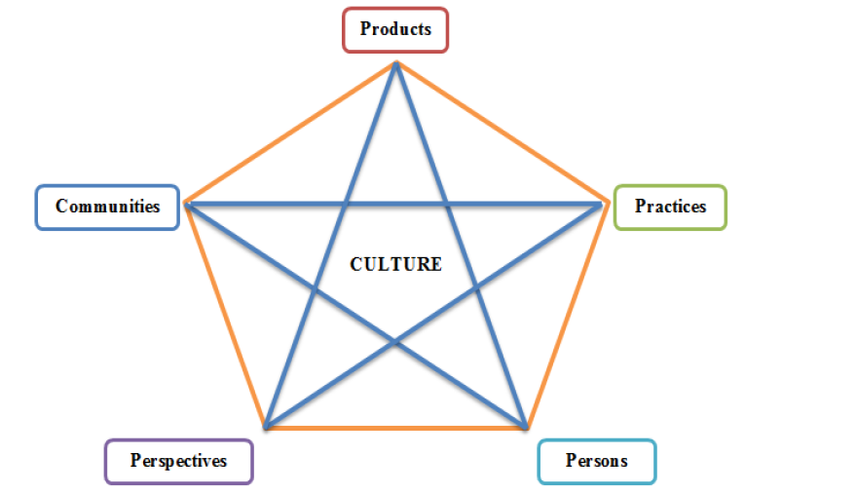
Figure 1. Moran’s Five Dimensions of Culture (adapted from Moran, 2001, p. 24) Font size 12 / Garamond /Single line space / Spacing 10 nk after /

Figure 2. Title / Font size 12 / Garamond /Single line space / Spacing 10 nk after /
USING QUALITATIVE DATA IN-TEXT
The analysis of the interview protocols showed that this lack of information is a negative factor that influenced practitioners’ attitudes towards the efficiency of curriculum change process. This point was illustrated by the following excerpt from Lecturer 13:
L13: “We did not have voice during this process. Nobody asked for our opinions. I do not think that anybody’s opinions were taken into consideration. It was a top down process, as usual.”
Another interviewee expressed similar concerns:
L20: “They claim that they had involved stakeholders in the process. But when we spoke with colleagues from different universities, nobody told that they had participated in this process. I want to know who participated in the process.”

